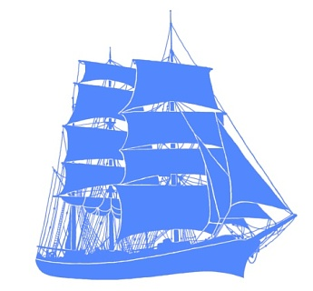 | MARITIME HERITAGE ASSOCIATION of VICTORIA Inc.  PO Box 408, Williamstown, Victoria 3016, Australia  Ph: (03) 9589 4575 Facs: (03) 9589 7736 Email: shiprex@alphalink.com.au  Web: www.mhav.net
January 2006

NEWSLETTER No. 11
This short Newsletter is to inform you of forthcoming activities associated with the Melbourne visit of the Sydney Heritage Fleet’s restored 3 masted barque James Craig and the Maritime Arts and Tall Ships Festival at Williamstown over the 4/5 February weekend, both taking place during the period that the Volvo Round - the - World Yacht Race entries are in Melbourne.

James Craig visit

At the time of writing the ship is off Cowes, Phillip Island and is due to berth at 21 South Wharf at 5.00pm on Saturday 21 January. The following morning the ship moves to Workshops Pier at Williamstown prior to our shared Bay sail charter from 11.00am that day. This and our later Bay charters on 24 and 31 January are all sold out as are all other charters during the ship’s Melbourne visit - a great result. We hope all involved have a wonderful time aboard and appreciate what Sydney has achieved in restoring and now operating this nineteenth century ship far more actively than any other such vessel anywhere worldwide. We are part of something very special. |  | 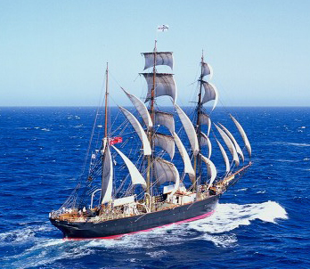
Some of our members were amongst 20 who travelled to Sydney for crew training on James Craig in December and these people, and others in Melbourne previously involved, will be supplementing the Sydney crew for Bay sails, and in some cases assisting to sail James Craig from and back to Sydney.

JAMES CRAIG PUBLIC INSPECTION
James Craig will be open for public inspection at the following times and locations. Sydney Heritage Fleet personnel provide details of all aspects of the ship during these inspections, an ideal opportunity for those not able to sail to see the ship - bring the kids.

At Workshops Pier, Williamstown. Melways Ref 56E9, enter from Ann St.
Weds 25 Jan – 10.00 – 4.00, $5 entry ($15 family)
Thurs 2 Feb – 10.00 – 12.00, ditto
Fri 3 Feb – 10.00 – 12.00, ditto
Sun 5 Feb – during Festival (see below), 10.00 – 4.00, gold coin

At Cunningham Pier, Geelong
Fri 27 Jan - 10.00 – 4.00, gold coin
Sat 28 Jan - 10.00 – 3.00, gold coin

It is recommended to arrive early for these visits (5 February in particular) as they may be very busy and numbers arriving may exceed available spaces on board.
Page 2

Maritime Arts and Tall Ships Festival, Williamstown
Saturday 4 and Sunday 5 February 2006
82 Nelson Place. Melway Ref 56E9
10.00 – 5.00 daily, Adults $5, Children $2, Family $12
See publicity poster enclosed

Please spread the word about this weekend, especially Sunday 5 Feb with James Craig at the Pier for inspection (show the kids a “real” sailing ship) and the RAN band from HMAS Cerberus playing maritime themes from 12.00 to 2.00pm. The poster enclosed is available in colour (as are Newsletters) from the MHAV website. Alternatively email for a copy. Please consider passing to friends and displaying on work notice boards, local shops or other public places.

James Craig will be the start boat off Station Pier, Port Melbourne for the Volvo In – Port yacht race on Saturday 4 February and there will be great activity afloat this day. A good viewing spot could be Point Gellibrand at Williamstown.

As part of preparation for this Festival and for James Craig’s visit and her crew, MHAV committee members Miles Allen and John Milne and have refurbished the site toilet block and other members have assisted in general site preparations. Thanks are due to all these people.

Replica Schooner Enterprize
Members may be interested in sailing on Enterprize from Williamstown during James Craig’s visit. On Thurs 26 Jan both vessels leave Williamstown for Geelong at 9.00. This could be an ideal photo opportunity. For the Festival on 4/5 Feb Enterprize will be conducting 1 hour sails from the site. See sailing schedule on website www.enterprize.com.au or phone 9397 3477.

Replica Bark Endeavour to visit.
After years sailing around the world the Endeavour, now owned by the Australian National Maritime Museum in Sydney, will berth in Docklands for the Commonwealth Games in March. The ship will be lowering the topgallant masts to permit transit upstream of the Bolte bridge and will be open to the public during the visit. Volunteer guides have been called for as for earlier visits, phone 9642 5266 or email volsoffice@anmm.gov.au if interested in assisting.

AGM
Our AGM was held on 22 November. The Committee remains unchanged with one member elected position vacant. If interested in joining the committee and assisting please make contact. The organizations represented on the committee also remain unchanged.

Developments at Williamstown
The James Craig visit and the Maritime Art and Tall Ships Festival above are events which showcase some aspects of our maritime heritage and other maritime interests, but the real aim is to ensure the Williamstown site is developed into a world class maritime heritage centre, open seven days a week and staging events such as the above as just one aspect of operations. After the February Festival and the return of James Craig to Sydney, our committee will be focussing on how we can contribute to the achievement of these longer term aims. Real progress over the last two years has been slow and has been largely event focussed. It is essential that a proper plan for site development now be prepared and a management structure installed with the skills necessary to achieve success.

Finally: Membership Renewals
Some members have not renewed for 2005/06. If there is a red dot on your address label please renew your subscription at the usual $5.00 cost as soon as possible.

Lindsay Rex
President

